 University Of Engineering & Technology Peshawar

**Circuit and system I**

**Lab report # 2**

**Fall 2020**

**Submitted by: Ashfaq Ahmad**

**Section: B**

**Reg No: 19PWCSE1795**

**Semester: 2nd**

**Submitted to:**

**Dr. faiz ullah**

**Department Of Computer System Engineering**

**OBJECTIVES:**

1. **we will be able to learn resistance and its units with detail.**
2. **We will learn that how we find the resistance of resister by color coding method.**

**APPARATUS:**

1**. The set of wires.**

**2 digital A.V.O meter**

**RESISTANCE:**

**The opposition offered to flow of current is called resistance**.

**UNIT OF RESISTANCE:**

**The standard unit of resistance is the**[**ohm**](https://whatis.techtarget.com/definition/ohm)**, sometimes written out as**

**a word and sometimes symbolized by the uppercase Greek letter omega Greek letter omega**

**OHM:**

* **Ohms are named after Georg Simon Ohm (1784-1854), a German physicist whostudied the relationship between**[**voltage**](https://www.fluke.com/en/learn/best-practices/measurement-basics/electricity/what-is-voltage)**,**[**current**](https://www.fluke.com/en/learn/best-practices/measurement-basics/electricity/what-is-current)**and resistance.**
* **When an electric current of one**[**ampere**](https://whatis.techtarget.com/definition/ampere)**passes through a component across which a potential difference (**[**voltage**](https://whatis.techtarget.com/definition/voltage)**) of one**[**volt**](https://whatis.techtarget.com/definition/volt)**exists, then the resistance of that component is oneohm.**

**EXPLANATIONOF RESISTANCE:**

**Resistance is inversely related to current. If abnormally high, one**

**possible cause (among many) could be damaged conductors due to burning or**

**corrosion. All conductors give off some degree of heat, so overheating is an**

**issue often associated with resistance.**

**The lower the resistance, the higher the current flow. Possible causesinsulators**

**damaged by moisture or overheating.**

**RESISTOR:**

**we use resistance in order to control flow of current in circuit.**

**COLOR CODING METHOD:**

**Here we have two ways to find the resistance value of a resistor. The color bands on the**

**Body of the resistor tells how much resistance it has. The Resistor Color Code system**

**is all well and good but we need to understand how to apply it in order to get the correct**

**value of the resistor. The “left-hand” or the most significant colored band is the band**

**which is nearest to a connecting lead with the colour coded bands being read from**

**left-to-right as follows:**

**Digit, Digit, Multiplier = Colour, Colour x 10colour Ohm’s (Ω**)

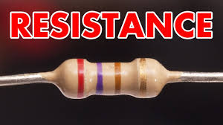

* **The reading direction might not always be clear. Sometimes the increased space between**

**band 3 and 4 give away the reading direction. Also, the first band is usually the closest to a lead. A gold or silver band (the tolerance) is always the last band.**

* **It is a good practice to check the manufacturer’s documentation to be sure about the used coding system. Even better is to measure the resistance with a multi-meter. In some cases this might even be the only way to figure out the resistance for example when the color bands are burnt off.**

**COLOR CODING TABLE:**

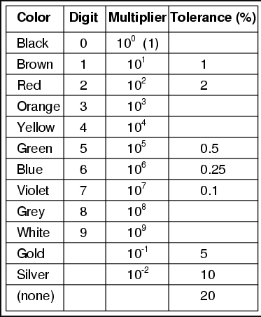

**The resistors always have a tolerance but what does this mean? It refers to the accuracy**

**to which it has been manufactured. For example if you were to measure the resistance**

**of a gold tolerance resistor you can guarantee that the value measured will be within**

**5% of its stated value. Tolerances are important if the accuracy of a resistors value is**

**critical to a designs performance.**

**EXPERIMENTAL RESULTS:**

|  |  |  |  |  |
| --- | --- | --- | --- | --- |
| **1ST BAND** | **2ND BAND** | **3RD BAND** | **TOLERANCE** | **RANGE** |
| Brown | Black | orange | **±5** | **22×±5** |
| Red | Red | Red | **±5** | **10±5** |
| Orange | Brown | orange | **±10** | **3±10** |
| Brown | Black | blue | **±5** | **10×±5** |
| Blue | Black | orange | **±20** | **60×±20** |